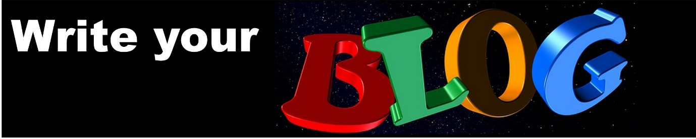Welcome to Week 6

Choose your path (1) the path you have always been on

Your weight is your responsibility. I am going to show you a mental exercise which will make that clear to every part of your mind.

Use your imagination for this hypnotic exercise

Imagine you are walking on a path. Then the path splits into two, going in two directions.

You stop.

Look around and you will see a sign, saying: “Your responsibility”. For the first time you really notice the direction of both paths.

One forks to the left and one to the right.

You sense very strongly that these paths represent possible futures for you. One way represents continuing to carry on the way you have been. Eating badly, putting on weight, becoming more and more unhealthy. You may even see a sign saying ‘old bad ways’ or perhaps ‘more of the same’. The other represents a change, a new way. This path may appear less distinct or you may not be able to see very far along it.

This is perfectly normal, it shows your mind beginning to adjust to a new way of thinking about things.

Take a moment to really get a sense of each path.

Clear the confusion
You may at this stage feel slightly conflicted or confused. This is fine, we are going to clear that confusion by exploring both paths in turn.

The path of the old way
So first of all turn to the path of carrying on in the old way. It probably looks quite dull, but wide and easy. It is a well-trodden path for you.

Begin to travel along this path and you will travel into a possible future. The future of carrying on as you have been. Notice how familiar and boring and dull everything looks as your trudge along in the same old way. Notice it is getting difficult to walk as you get heavier, perhaps your thighs are rubbing together. Perhaps your knees hurt, and you are getting out of breath as you trudge along.

Look around you, at the sides of the path you can see piles of junk food, all the rubbish you eat. You might even see yourself, stuffing away. You feel embarrassed perhaps a bit shamed as you trudge along.

A bit later you see yourself, at an important event. You have tried your best to look ok, but your clothing is too tight and bunched up. Bulges are showing and you feel glances from colleagues as you go about your business.

You see a slimmer, healthier colleague and notice how confident and happy he/she looks. He/she is at the centre of a group and everyone is paying attention to what they are saying. Your colleague smiles and laughs.

You trudge on seeing yourself eating.
Notice how grey and dull everything looks. Notice how miserable you feel.

Well it doesn’t have to be like that. Next time I’ll show you how to imagine and get a much better future for yourself by exploring the other path.

Last time you saw how miserable life will be if you carry on the way you have been. Well, it doesn’t have to be like that. This time you will take the new path, the path of change.

The new hypnotic path
So turn to that path now. Begin to travel along it. You may notice it is a bit hard at first. It might twist and turn or you might lose a sense of its direction, or perhaps it goes uphill. This is fine, it is your mind adjusting to change.

As you progress along the path you will think of all the advantages for you of being lighter. The path will become easier, perhaps brighter and sunnier or easier to see.

You are breathing more easily now. Feel the lovely fresh air entering your lungs. Notice you are enjoying this journey. Your body feels as if it is working well. You already feel lighter. More confident perhaps.

Look at yourself being different
Look to the sides of the path. You will see yourself doing things differently, doing things in a new way.

Focus now on food - notice a scene where you can see yourself eating healthy foods. As you develop this scene you become attracted to healthy natural foods - they are what you want to eat.

Notice you enjoy eating and you stop when you feel full. Get that feeling - you now begin to feel how it feels to eat enough to be comfortably full.

If you think about the old unhealthy choices, you used to make, you see them for what they are. Junk food which is harming you.

You turn away from those foods: they are no longer attractive to you.

You begin to notice different things new things which you are doing.

Perhaps you see yourself eating regular healthy meals. Notice how healthy foods seem somehow more attractive.

Notice how you are looking. You are already lighter. You look more confident, prouder somehow. Happier, more fulfilled. Notice how you are feeling, better already, healthier and calmer.

You continue to travel along this path into a healthy happy future. One where you are in control of food. Notice you no longer feel ashamed of your eating. You are now in control.

Spend some time enjoying how good it feels to feel like this as you travel into this future.

Allow yourself to arrive at an event, a time where it is really important to you that you have done it.

Take the lighter, more confident you into the centre of the event. Notice how you are behaving. What are you saying? How do you relate to the people around you? How do you look? What are you wearing?

Make everything you are experiencing as real and as detailed as you can. Take your time. Use all your senses.

Notice how others react and relate to you. Notice how your new found confidence is inspiring respect. You are taken more seriously.

Notice how happy you are feeling.

Practise this as much as you want. You will be surprised at how many new things you find on your path.

