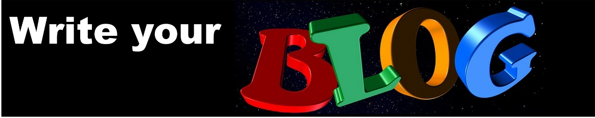Changing your story and getting some balance

Hello and I hope you are ready to confront some of the myths, personal beliefs and stories which you might tell yourself about your weight.
Often these myths have a family history – perhaps you tell yourself that everyone in your family is fat so it must be in your genes, or perhaps you have a slow metabolism. Or your myths might be about certain characteristics you have which you somehow believe are unchangeable. So do you tell yourself: “I have no willpower,” or “I just enjoy sweet things, I always have.”

You are the same as a slim person

Well I’ve news for you. You are just the same as a slim person. Your genes are no different and science has shown that nearly everyone has a metabolism which operates at a broadly similar rate. And you have your human share of willpower.

These are just stories you tell yourself and you can change your story. Treat them like excuses that's what they are. Nothing more.

Change your story

So let’s take a couple of examples of how you can change your story. See what you think and ask if you can apply this way of thinking to your particular myths and excuses.

The willpower example

So you haven’t got any willpower you say. Well, I bet you got up and went to work this morning – perhaps you didn’t want to, but you did. You are an adult and you know you need to do certain things to get certain outcomes. It’s the same with food – you want to lose weight so that means you need to do certain things. Do x get outcome y.

If you can think like this to get to work, to look after your family and all the other things you do, you can think like this about food. It’s just food, it doesn’t have supernatural power to make you do what you don’t want to. So change your story around food – feel proud that you control it. That is looking after yourself well, isn’t it? Do x (eat well) and you will get outcome y (a healthy weight)

Good things in balance

Or what if you say: “I just enjoy sweet things, I can’t resist cake.” I’m sure there are lots of things you enjoy but you don’t expect to do them all the time do you? They are rare pleasures and as an adult you know you cannot have them every day.

The holidays and cake example

You enjoy holidays don’t you? But you don’t run away and hide when the holiday is finished saying “I can’t resist the beach,” You sigh, get yourself together and get on the plane for home. Then you settle back into life and look forward to the next holiday. You live life in balance. (And if you think about it, holidays all the time would probably get boring. They are good because they are special). Apply this attitude to cake. Eat a cake then don’t eat two. Go and do something else. That’s balance.

So what are your myths, have a think about them and change your own personal story.

