Welcome to Week 9

Portion sizes

It is very easy for portion sizes to creep up so here is a handy guide to remind you to keep it small. Picture the object mentioned. Portion sizes should be this size

Cereal a tennis ball

salad dressing egg cup

nuts will sit easily in your hand

cheese a ping-pong ball

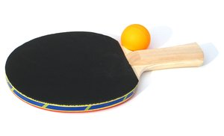

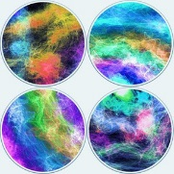

hamburger drinks coaster

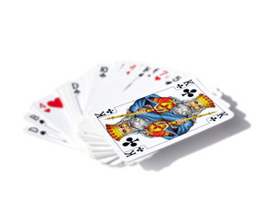

beef steak pack of cards

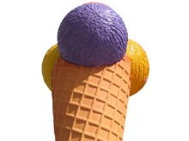rice one scoop of ice cream

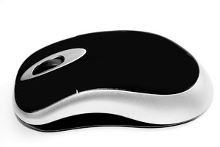potato a computer mouse

roll a tennis ball

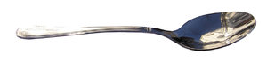butter teaspoonful

fruit a tennis ball

cooked pasta half a wine glass

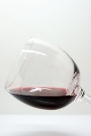



100 calorie snacks

|  |  |
| --- | --- |
| You don’t have to open the biscuit tin if you are feeling hungry between meals. Here are some suggestions for snack at about 100 calories |  |
| 1 apple and a handful of grapes      2 rye crispbreads topped with 2tbsp guacamole    1 pot low-fat natural yoghurt with a handful of raspberries      8tbsp salsa and carrot sticks    8 unsalted almonds    1 slice wholegrain toast with 1tsp low-fat spread and 1 tomato      Small bowl fresh vegetable soup |