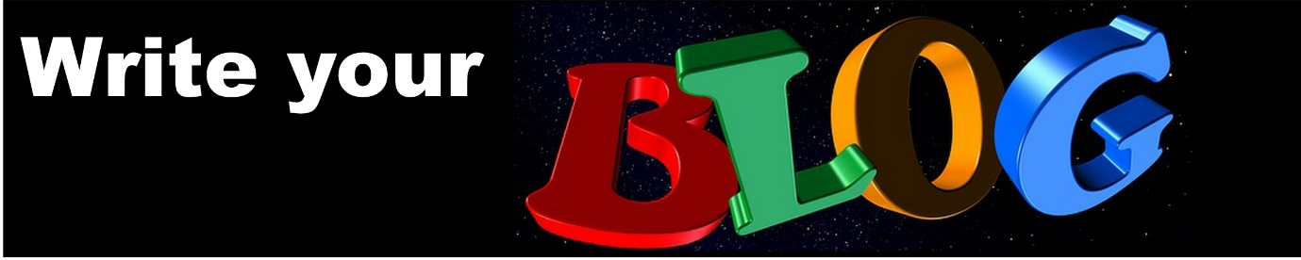Welcome to Week 12

A couple of great stress busters to break bad habits

Anxiety can be a habit and just like any other habit it can be changed. A great little book which came out last year gives a whole lot of simple techniques for dealing with those thought habits which get you into a stressful mindset. It was written by the well-known cognitive hypnotherapist Kim Wilson. It is full of great information and explanations of how stress works and why we get stressed.
Here are a couple of favourites which I would like to share with you.

“Glass ball or rubber ball”
“Whether we are in full time employment, part-time work or are full time home-workers, we all have things that we NEED to get done in a day. This can be as simple as walking the dog, doing the laundry or picking the kids up from school. It may be a call that has to be made or a report that has to be written but all of us have things that are important to us to complete.

Step One: your list
The first thing to do is make a list of all the things that you need to do - lists are great when they are used well - more about that later.

Step Two: if you dropped it?
When you've written your list I want you to look at each item on it and think of whether, if you dropped that item from your things to do today would it bounce like a rubber ball i.e. could you do it tomorrow or would it break like a glass ball i.e. a project that has a hard deadline that will have consequences if not done.

Step Three: be ruthless
As you go through your list be ruthless. Although we often think that everything has to be done right now a lot of what we think needs doing is actually a rubber ball. For example, if you are a home-worker and run a busy household I often hear people say that they have to do the laundry, they must do the vacuuming, they need to pick up their children from School. When you think about it carefully only of those things is a Glass ball -collecting the children from school. Vacuuming and laundry are rubber balls - if you don't do them today what are the consequences? I would guess that they would be very slight.
This technique is also useful for work. Your boss has asked you to do a handful of things on top of the already mountainous stack of work sitting on your desk. Make a list and go through each item, G - glass ball or R- rubber ball. Even if you find half the stack will bounce into tomorrow then you've halved your stress for that day.”

“Kitten or lion”

“So you've been through your list, you've been ruthless but no matter how many times you look at it all your items on the list have a big fat G besides them, what now?

If there is absolutely no doubt in your mind that all the things you have to do that day are glass balls and that by not doing any one of them there will be serious consequences then let me introduce you to prioritisation by consequence, otherwise known as would you rather be bitten by a kitten or a lion.

Prioritisation isn't always easy especially if we are already in a state of stress when we are trying to decide what to do first. Sometimes looking at the consequence of not doing something can give us a different perspective and help us make an informed decision.

So imagine that you have 20 things that you have to do today - they are all made of very delicate glass and you have no doubt that each would break if were not completed immediately. Look at each item on your list and think about the consequence of not doing it.

Some tasks on your list will have a bigger consequence than others. Not doing the laundry for example could be considered as having a small consequence, a bit like being bitten by a kitten. The damage will be small and superficial. You may not have a pair of clean socks for tomorrow, but that is unlikely to be life changing. Missing an important deadline at work however may have much
more damaging consequences; it could mean that your ability to do your job is questioned or that you lose an important deal. It's more like being bitten by a lion, the damage is much greater and there is most certainly a longer recovery period to get back to where you were.

If you know that whatever you do you are going to receive a bite then would you rather be bitten by a kitten or a lion? Prioritise your lion tasks and then if you have time go and play with the kittens.”

Thanks for those Kim if you would like to see more you can get Kim’s book, in print or on Kindle at http://ow.ly/ZHa8O

